New Objective Numeracy Measures
A-NUM:
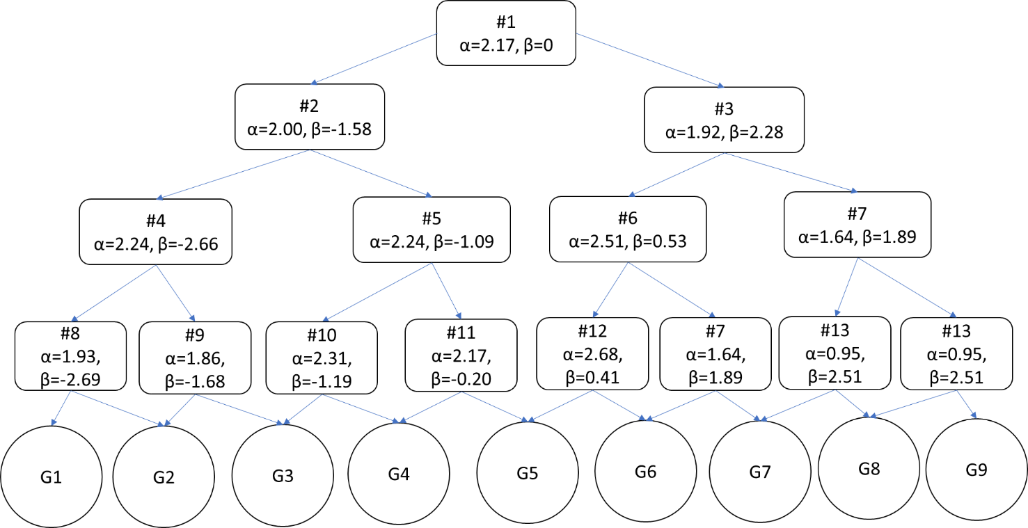
Figure 1. The Structure of the Adaptive Numeric Understanding Measure (A-NUM) with Item Parameters
Table 1. Items that Compose the A-NUM in Figure 1’s Order
# | Item
1 | Imagine that you have a five-sided die (the sides of which show 1, 2, 3, 4, 5), and we throw it 150 times. On average, out of these 150 throws how many times would this five-sided die show an odd number (1, 3, 5)? _____ throws
2 | A medical study will either give people medicine A or medicine B. Each person has an equal chance to get medicine A or B. If there are 536 people in the study, about how many are expected to get medicine A? ___ people
3 | If the probability of getting the common cold is 60% in 1 year, what is the probability of getting the common cold in 2 years? _____%
4 | If Person A's risk of getting a disease is 7% in twenty years, and Person B's risk is double that of A's, what is B's risk of getting the disease in twenty years? ____ % in twenty years
5 | If the chance of getting a disease is 60 out of 300, this would be the same as having what percent chance of getting the disease? ______ %
6 | The town of Jamesville has a pole that is red, blue and green standing in the center of town. One-third of a pole is painted red, one-half of the pole is painted blue, and three feet of the pole is painted green. What is the height of the pole? ______ feet
7 | In a lake 20% of fish are red. A red fish is poisonous with a probability of 20%. A fish that is not red is poisonous with a probability of 15%. What is the probability that a poisonous fish in the lake is red? _______%
8 | What is 74% of 100 people? ________ people
9 | If a class of 200 people includes 50 men, this would be the same as the class being what percent men? ____%
10 | If 70% of basketball players on a college basketball team are over six feet tall and there are 20 players on the team, how many players on the team are shorter than six feet tall? ___ players
11 | In a field containing 1000 squirrels, 40% of squirrels are striped and a striped squirrel is rabid with a probability of 20%, on average, how many squirrels are there in the field that are rabid and have stripes? ___ squirrels
12 | Allenton College has a column that is green, white, and yellow (the school’s colors) standing in front of the campus library. One-third of the column is painted green, one-half of the column is painted white, and four feet of the column is painted yellow. What is the height of the column? ______ feet
13 | In a box of cookies, 25% have chocolate chips, 25% have raisins, and 50% are plain. 40% of the chocolate chip and plain cookies aren’t fresh, and 30% of the raisin cookies aren’t fresh. What percentage of cookies that aren’t fresh are raisin cookies? __ %
*1-NUM item is in bold
4-Item NUM:
Table 2. The Items that Compose the 4-NUM in Order of Difficulty (Easiest to Hardest)
# | Item
1 | Suppose that you are buying a gallon of milk at the grocery store. There are two options for the same brand of milk: buying 4 quarts at $2.50 per quart or buying 1 gallon for $8.00. What is the cost per quart (1 gallon=4 quarts) of the better priced milk? $______ per quart
2 | Imagine you are throwing a fair six-sided die (the sides of which show 1, 2, 3, 4, 5, 6) 120 times. On average, how many times would you expect this die to show a number less than 5 (1, 2, 3 or 4)? ______ out of 120 throws.
3 | Out of 300 fruits, 200 are apples and 100 are bananas. Out of the 200 apples, 90 are green. Out of the 100 bananas, 30 are green. What is the probability that a randomly picked green fruit will be an apple? ____ %
4 | In a field 40% of snakes are striped, 30% brown and 30% black. A striped snake is poisonous with a probability of 10%. A snake that is not striped is poisonous with a probability of 20%. What is the probability that a poisonous snake in the field is striped? __ %

